13.3.3 Editors - Video Sequence Editor - Sidebar - Sequencer - Strip tab
Detailed table of content 1
Strip Tab 6
Strip tab header 6
Scene Panel 6
Scene Property 6
Input 6
Mask Panel 7
Mask Property 7
Effect Strip Panel 8
Effect strip type Color Mix 8
Effect strip type Text 8
Effect strip type Gaussian Blur 10
Effect strip type Multicam 10
Effect strip type Speed 10
Effect strip type Color 11
Effect strip type Transform 11
Effect strip type Glow 12
Effect strip type Wipe 12
Effect strip type Alpha over Drop 13
Effect strip type Multiply 13
Effect strip type Gamma Cross 14
Effect strip type Alpha Under 14
Effect strip type Alpha Over 14
Effect strip type Subtract 15
Effect strip type Add 15
Effect strip type Crossfade 15
Adjust Panel 16
Compositing subpanel 16
Transform subpanel 16
Video subpanel 17
Color subpanel 17
Time subpanel 17
Sound subpanel 18
Custom Properties Panel 18
Add 19
Edit 19
Remove 19

Detailed table of content
Detailed table of content
Detailed table of content 1
Strip Tab 6
Strip tab header 6
Scene Panel 6
Scene Property 6
Scene Browser 6
Scene edit box 6
Remove 6
Input 6
Camera settings 6
Volume 6
Camera 7
Show Grease Pencil 7
Transparent 7
Sequencer settings 7
Volume 7
Mask Panel 7
Mask Property 7
Mask Browser 7
Mask edit box 7
Fake User 7
Remove 7
Effect Strip Panel 8
Effect strip type Color Mix 8
Input 1 8
Input 2 8
Swap Strips 8
Blend Mode 8
Blend Factor 8
Effect strip type Text 8
Text 8
Wrap Width 8
Style subpanel 8
Font property 9
Font browser 9
Open 9
Font Edit Box 9
Fake User 9
Open Font 9
Remove 9
Size 9
Color 9
Shadow 9
Shadow color 9
Layout subpanel 9
Location X/Y 9
Anchor X/Y 9
Effect strip type Gaussian Blur 10
Input 1 10
Size X 10
Y 10
Effect strip type Multicam 10
Source Channel 10
Cut to 10
Effect strip type Speed 10
Input 1 10
Stretch to Input Strip Length 10
Use as Speed 10
Speed Factor 10
Frame Number 10
Scale to Length 11
Multiply Speed 11
Frame Interpolation 11
Effect strip type Color 11
Color Picker 11
Effect strip type Transform 11
Input 1 11
Interpolation 11
Translation Unit 11
Position X 11
Y 11
Uniform scale 11
Scale X 12
Y 12
Rotation 12
Effect strip type Glow 12
Input 1 12
Threshold 12
Clamp 12
Boost Factor 12
Blur Distance 12
Quality 12
Only Boost 12
Effect strip type Wipe 12
Input 1 12
Input 2 12
Swap Inputs 13
Transition type 13
Direction 13
Blur width 13
Angle 13
Default Fade 13
Effect strip type Alpha over Drop 13
Input 1 13
Input 2 13
Swap Inputs 13
Default Fade 13
Effect strip type Multiply 13
Input 1 13
Input 2 13
Swap Inputs 14
Effect strip type Gamma Cross 14
Input 1 14
Input 2 14
Swap Inputs 14
Default Fade 14
Effect strip type Alpha Under 14
Input 1 14
Input 2 14
Swap Inputs 14
Default Fade 14
Effect strip type Alpha Over 14
Input 1 14
Input 2 14
Swap Inputs 15
Default Fade 15
Effect strip type Subtract 15
Input 1 15
Input 2 15
Swap Inputs 15
Effect strip type Add 15
Input 1 15
Input 2 15
Swap Inputs 15
Effect strip type Crossfade 15
Input 1 15
Input 2 15
Swap Inputs 15
Default Fade 16
Adjust Panel 16
Compositing subpanel 16
Blend 16
Opacity 16
Transform subpanel 16
Mirror 16
Offset 16
Position X 16
Y 16
Crop 16
Video subpanel 17
Strobe 17
Tracker - Stabilize 2D Clip 17
Distortion - Undistort Clip 17
Reverse Frames 17
Color subpanel 17
Saturation 17
Multiply 17
Convert to Float 17
Time subpanel 17
Channel 17
Start 17
Duration 17
End 17
Strip Offset Start 18
End 18
Hold Offset Start 18
End 18
Current Frame 18
Sound subpanel 18
Volume 18
Pitch 18
Pan 18
Display Waveform 18
Mono 18
Custom Properties Panel 18
Add 19
Edit 19
Remove 19

Strip Tab

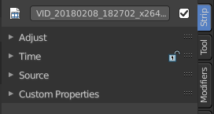
The strip tab contains all the strip type related settings. For the different strip types see the Add menu.

Some panels have the same content for all strip types. Some not. Some strip types have their own panels.

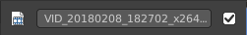
Strip tab header
In the strip tab header you will see an icon for the current strip type. The name of the strip. And a checkbox to set this strip active.
The strip can be renamed by double clicking left into the edit box.

Scene Panel

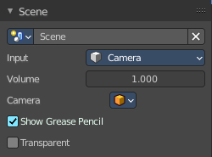
This panel just shows with strip type scene.

Scene Property

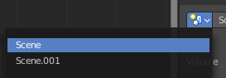
Scene Browser
A scene browser that contains the available scenes in the file.

Scene edit box
The name of the scene. It can be renamed by double clicking into the edit box.

Remove
Remove the scene as the active one. Note that the scene is still available in the scene browser.

Input
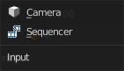
Type of input to use. The camera of the scene. Or a file from the sequencer in this scene.

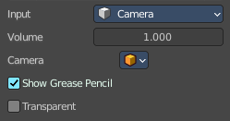
Camera settings

Volume
The audio volume.

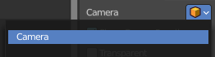
Camera
Which camera of the scene to use.

Show Grease Pencil
Show grease pencil strokes in OpenGL previews.

Transparent
Use a transparent background.

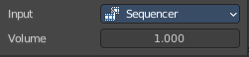
Sequencer settings

Volume
The audio volume.

Mask Panel

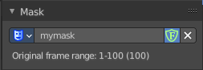
This panel just shows with strip type Mask.

Mask Property

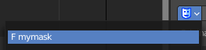
Mask Browser
A mask browser that contains the available masks in the file.

Mask edit box
The name of the scene. It can be renamed by double clicking into the edit box.

Fake User
Assign a fake user to this mask. Fake users is a odd concept to keep data in the scene even if it has no user somewhere. The fake user is then a dummy user so that the object is not deleted when saving the scene.

Remove
Remove the scene as the active one. Note that the scene is still available in the scene browser.

Effect Strip Panel
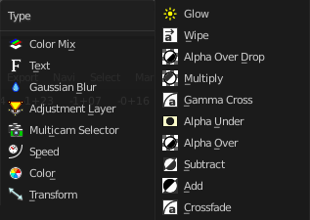
Settings for the single effect strip types.

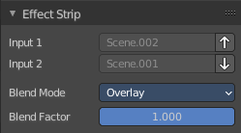
Effect strip type Color Mix

Input 1
The first strip.

Input 2
The second strip.

Swap Strips
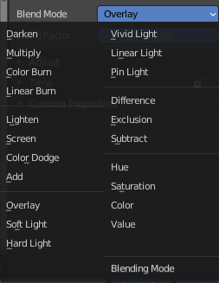
Swap the strips.

Blend Mode
The color blend mode to use.

Blend Factor
The blend factor. 1.000 means 100%.

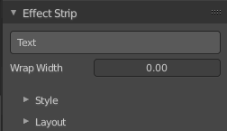
Effect strip type Text

Text
The text to displayed.

Wrap Width
World wrap width as factor. Zero disables the wrap.

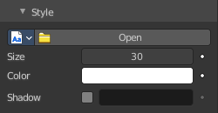
Style subpanel

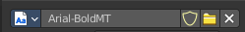
Font property
When no font is loaded then the internal font is used.

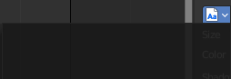
Font browser
The list of loaded fonts. This list is empty by default.

Open
Load a font.

Font Edit Box
Display the current active font. You can rename the font by double clicking in the edit box.

Fake User
Assign a fake user to this font. Fake users is a odd concept to keep data in the scene even if it has no user somewhere. The fake user is then a dummy user so that the object is not deleted when saving the scene.

Open Font
Load a font.

Remove
Remove the selected font as the active one. Note that the font is still in the list then.

Size
Size of the text.

Color
The text color.

Shadow
Creates a shadow of the specified color under the text.

Shadow color
The color of the shadow. Clicking at the color field opens a color dialog.

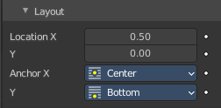
Layout subpanel

Location X/Y
Positions the text on the X, Y axis.

Anchor X/Y
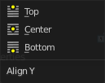
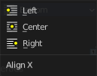
Horizontal (X) or vertical (Y) anchor point of the text relative to the location.

Effect strip type Gaussian Blur

Input 1
The strip to blur. This strip cannot be changed. You need to apply the effect with the correct strip selected.

Size X
The size of the blur along X axis.

Y
The size of the blur along Y axis.

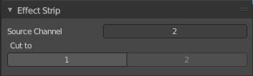
Effect strip type Multicam

Source Channel
The channel which the Multicam Selector gets its input from.

Cut to
Cuts the Multicam strip at the current frame and changes the Source Channel automatically to the selected channels.

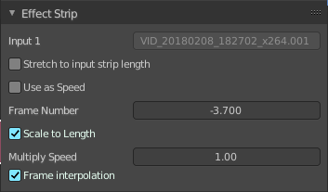
Effect strip type Speed

Input 1
The strip to blur. This strip cannot be changed. You need to apply the effect with the correct strip selected.

Stretch to Input Strip Length
Automatically calculates the Speed Factor based on the length of the input strip. So if you make a strip 1/2 the original size the sequence will play back at 2 times the speed.

Use as Speed
Calculates the scale value based on a Speed Factor.
Note! You will have to manually re-adjust the length of the strip accordingly.

Speed Factor
Multiplies the current speed of the sequence by this value. So, a value of 0.5 will make the sequence half as fast while 2 would make the sequence twice as fast.

Frame Number
Specifies a frame to remap the current frame to, for example, setting this value to 50 displays the 50th frame. This can then be manually keyframed to recreate the animation.

Scale to Length
Maps the frame range on a 0-1 scale. For example, using this and a Frame Number of 0.5 will select the frame halfway through the sequence.

Multiply Speed
A multiplier applied after all other calculations.

Frame Interpolation
Crossfades between frames to reduce screen tearing when the speed is slower than the original frame rate.

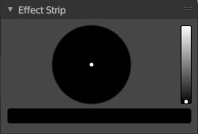
Effect strip type Color

Color Picker
Adjust the color of the color strip.

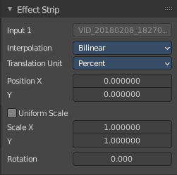
Effect strip type Transform

Input 1
The strip to transform. This strip cannot be changed. You need to apply the effect with the correct strip selected.

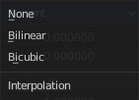
Interpolation
The interpolation type for the transform.

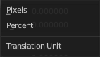
Translation Unit
The measure unit to use for the transform.

Position X
Amount to move the input in the X axis.

Y
Amount to move the input in the Y axis.

Uniform scale
Scale uniformly, preserve the aspect ratio.

Scale X
Amount to scale the input in the X axis.

Y
Amount to scale the input in the Y axis.

Rotation
Degrees to rotate the input.

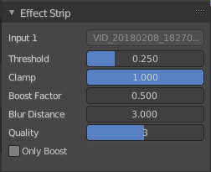
Effect strip type Glow

Input 1
The strip to use. This strip cannot be changed. You need to apply the effect with the correct strip selected.

Threshold
Minimum intensity to trigger a glow.

Clamp
The brightness limit of intensity.

Boost Factor
Brighness multiplier.

Blur Distance
The radius of the glow effect.

Quality
The accuracy of the blur effect.

Only Boost
Show the glow buffer only.

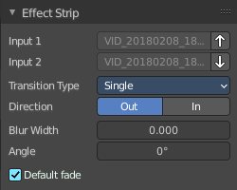
Effect strip type Wipe

Input 1
The first strip.

Input 2
The second strip.

Swap Inputs
Swap the two strips.

Transition type
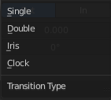
The wipe effect type.

Direction
The direction of the wipe.

Blur width
The width of the blur edge, relative to the image size.

Angle
The edge angle.

Default Fade
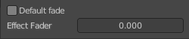
Use the builtin default effect time, which is as long as the fade clip. Or adjust the effect time.

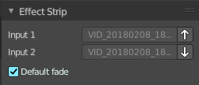
Effect strip type Alpha over Drop

Input 1
The first strip.

Input 2
The second strip.

Swap Inputs
Swap the two strips.

Default Fade
Use the builtin default effect time, which is as long as the fade clip. Or adjust the effect time.

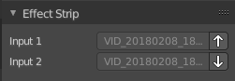
Effect strip type Multiply

Input 1
The first strip.

Input 2
The second strip.

Swap Inputs
Swap the two strips.

Effect strip type Gamma Cross

Input 1
The first strip.

Input 2
The second strip.

Swap Inputs
Swap the two strips.

Default Fade
Use the builtin default effect time, which is as long as the fade clip. Or adjust the effect time.

Effect strip type Alpha Under

Input 1
The first strip.

Input 2
The second strip.

Swap Inputs
Swap the two strips.

Default Fade
Use the builtin default effect time, which is as long as the fade clip. Or adjust the effect time.

Effect strip type Alpha Over

Input 1
The first strip.

Input 2
The second strip.

Swap Inputs
Swap the two strips.

Default Fade
Use the builtin default effect time, which is as long as the fade clip. Or adjust the effect time.

Effect strip type Subtract

Input 1
The first strip.

Input 2
The second strip.

Swap Inputs
Swap the two strips.

Effect strip type Add

Input 1
The first strip.

Input 2
The second strip.

Swap Inputs
Swap the two strips.

Effect strip type Crossfade

Input 1
The first strip.

Input 2
The second strip.

Swap Inputs
Swap the two strips.

Default Fade
Use the builtin default effect time, which is as long as the fade clip. Or adjust the effect time.

Adjust Panel
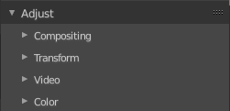

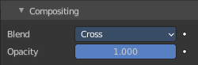
Compositing subpanel

Blend
The blend method to control how the strip combines with other strips.

Opacity
How much the strip color affects other strips.

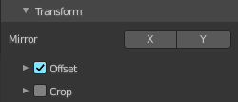
Transform subpanel

Mirror
Flip on the X and/or Y axis.

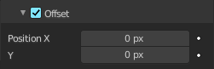
Offset
Translate image before processing.

Position X
The X offset.

Y
The Y offset.

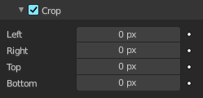
Crop
Crop image before processing.

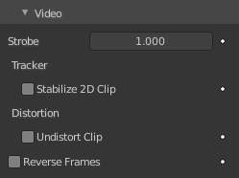
Video subpanel

Strobe
Don't display every frame, but just every nth frame.

Tracker - Stabilize 2D Clip
Strip type Clip. Use the 2D stabilized version of the clip.

Distortion - Undistort Clip
Strip type Clip. Use the undistorted version of the clip.

Reverse Frames
Reverse the frame order.

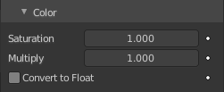
Color subpanel

Saturation
The intensity of the input color.

Multiply
Multiply colors by this factor.

Convert to Float
Convert input to float data.

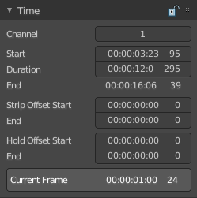
Time subpanel
Time related settings.
The first value is the time in seconds. The second value is the frame.

Channel
The channel of the strip.

Start
The start frame of the strip.

Duration
The duration of the strip.

End
The end frame of the strip.

Strip Offset Start
The start position of the strip in the timeline.

End
The end position of the strip in the timeline.

Hold Offset Start
Animation start offset.

End
Animation end offset.

Current Frame
Info box that displays the position of the frame cursor.

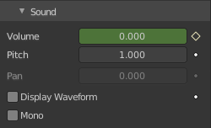
Sound subpanel

Volume
The volume of the audio clip.

Pitch
Playback pitch of the sound.

Pan
Playback panning of the sound (requires a mono source file)

Display Waveform
Display the waveform inside of the audio clip

Mono
Turn the output to mono.

Custom Properties Panel


Here you can define custom properties that can be used for scripting.

Here you might also find custom properties from addons or scripts.

Add
Adds a new property.


Edit
Opens a panel where you can adjust the settings for the custom property.

Remove
Removes the property.

